NOTE: IMPORTANT FACTS ABOUT [www.corporatecateringonline.com](http://www.corporatecateringonline.com) WEBSITE:

Website is entirely custom-built and has 2 Shopping Cart Setups:

1. Option CATERING opens a shopping cart that automatically adds Minimum Order requirement, and charges 10% of total ordered amount for Delivery Fee
2. Option EMPLOYEE MEAL PREP (VIRTUAL CAFÉ) does not have minimum order requirement and excludes delivery fee

This is important as some of the POUPUP windows are linked to one or another shopping cart and checkout options

UPDATES TO WEBSITE NEEDED:

**ADD** this logo to website header (to the right site where existing logo is – NOTE: if logo existing on webpage currently needs to be reduced in size or replaced please contact me to discuss) 

**REMOVE** dotted-line appearing between Home page header and featured pictures

**ADD** new category Covid-19 Menu to the header and remove word ‘Menu’ on Catering Menu

i.e. it should now look like this: Home Catering Covid-19 Menu Meal Prep Contact Us

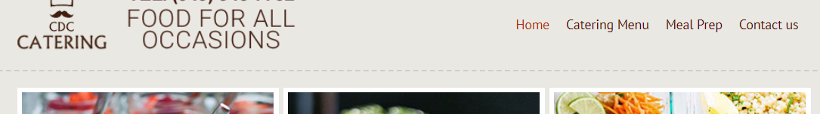

*Covid-19 Menu is a link - that leads to TOUCH-LESS DELIVERY MENU (please see following updates below)

**REPLACE** existing picture on CONTACT LESS DELIVERY with this picture (cut out left and right if needed)

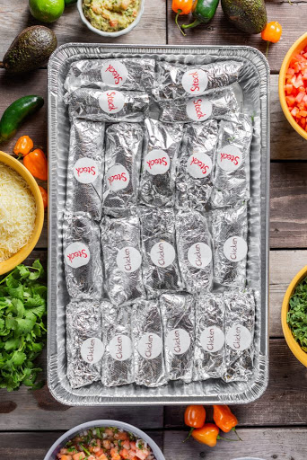

and ADD this sign hoovering over above picture to the lower-right corner of the picture 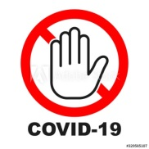

**CHANGE** title under this picture (CONTACT-LESS DELIVERY link) into now **TOUCH-LESS DELIVERY MENU**

* Currently, when click on this title/link it opens up a popup – this popup needs to be bypassed and link should open page with Boxed-Lunches Menu

(see following steps to know exactly which page):

Click **CATERING** on home page

Click [Boxed Lunches Menu](javascript:void(0);)

Basically, we want to bypass popup that currently opens in CONTACT-LESS DELIVERY - and go directly to Boxed Lunches Menu page

*\*Another way to open same Boxed Lunches Menu page that we want to link to this options is: click on CONTACT-LESS DELIVERY – when popup opens click on See Our Menu in CATERING – then click Boxed Lunches Menu in that second small popup*

**TEXT** under this option and bullet points need following update 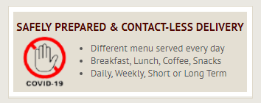

* REMOVE WHITE FRAME (remove that box) and Replace Title in this box with:

**NO TOUCH COVID-19 ServSafe DELIVERY**

* Replace “hand” icon with



AND BULLET POINTS with:

* Individually packed and labeled items
* Sanitized and 100% TOUCH-LESS
* Daily Deliveries

**UPDATE TEXT** under this section (new text):

For your safety – order selection of individually packaged items. With COVID-19 we took extreme measures to meet CDC and Health authority guidelines and recommendations and implemented new standards with NO CONTACT while cooking, and 100% CONTACT-LESS delivery. Click below to see available menu items or order your contact-less delivery by phone at (949) 945-7702

CHANGE text inside ORDER button into See more…

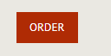

*Click on ORDER(now ‘See more…’) button link opens up same page as click on **TOUCH-LESS DELIVERY MENU**

(end of this section)

CATERING SECTION

**REMOVE** POPUP that appears on **CATERING** option

(WOULD YOU LIKE TO SEE OUR SPECIALS –needs to be removed – and CATERING SPECIALS page opens instead)

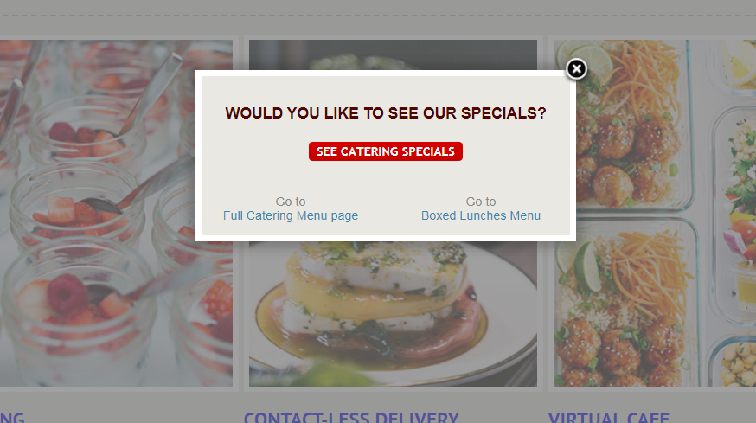

* Above popup appears once you click **CATERING** on home page and needs to be removed
* Instead – link needs to lend on SEE CATERING SPECIALS (sample of page below)

*It currently works properly (it lends on CATERING PSECIALS page) if you click on  icon, or if you click on OPEN buttun under that catergory

**Also, for CATERING SPECIALS page from the popup (the one that we want to remove) click on **See Catering Specials**

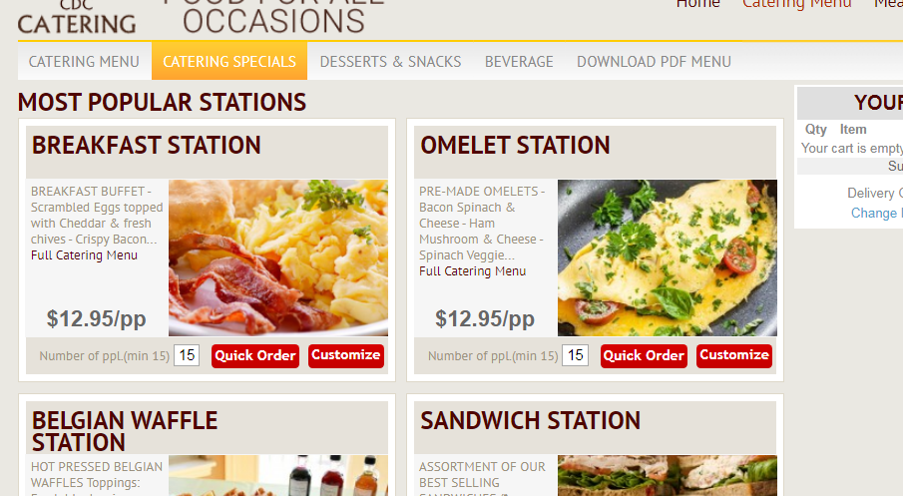

**REPLACE** this option title/link **CATERING** into **TRADITIONAL CATERING**

**REPLACE PHOTO** on home page for **CATERING** option

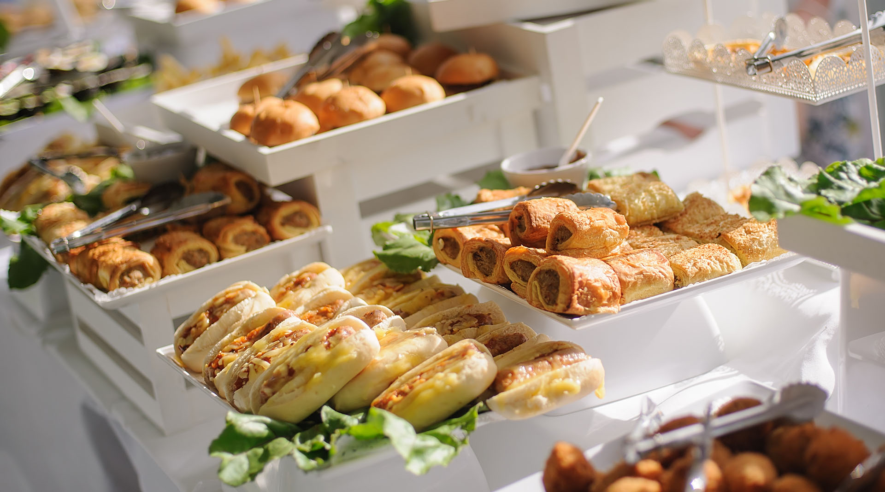

**DESCRIPTION under this option needs update** - title and bullet points need following update: 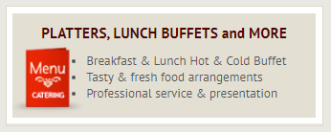

* REMOVE WHITE FRAME (remove that box) and replace Title in this box with:

**TRAYS PLATTERS BUFFET STYLE CATERING**

* REPLACE bullet point text with:
* Traditional Office Catering
* Gourmet Breakfast and Lunch Buffet
* Professional Setup and Presentation

**ALSO CHANGE text** inside ORDER button from OREDR to See more…



EMPLOYEE MEAL PREP

**CHANGE** **section’s title** **VIRTUAL CAFÉ** into now **EMPLOYEE MEAL PREP**

**REPLACE PHOTO** on home page for **VIRTUAL CAFÉ (now EMPLOYEE MEAL PREP)** section

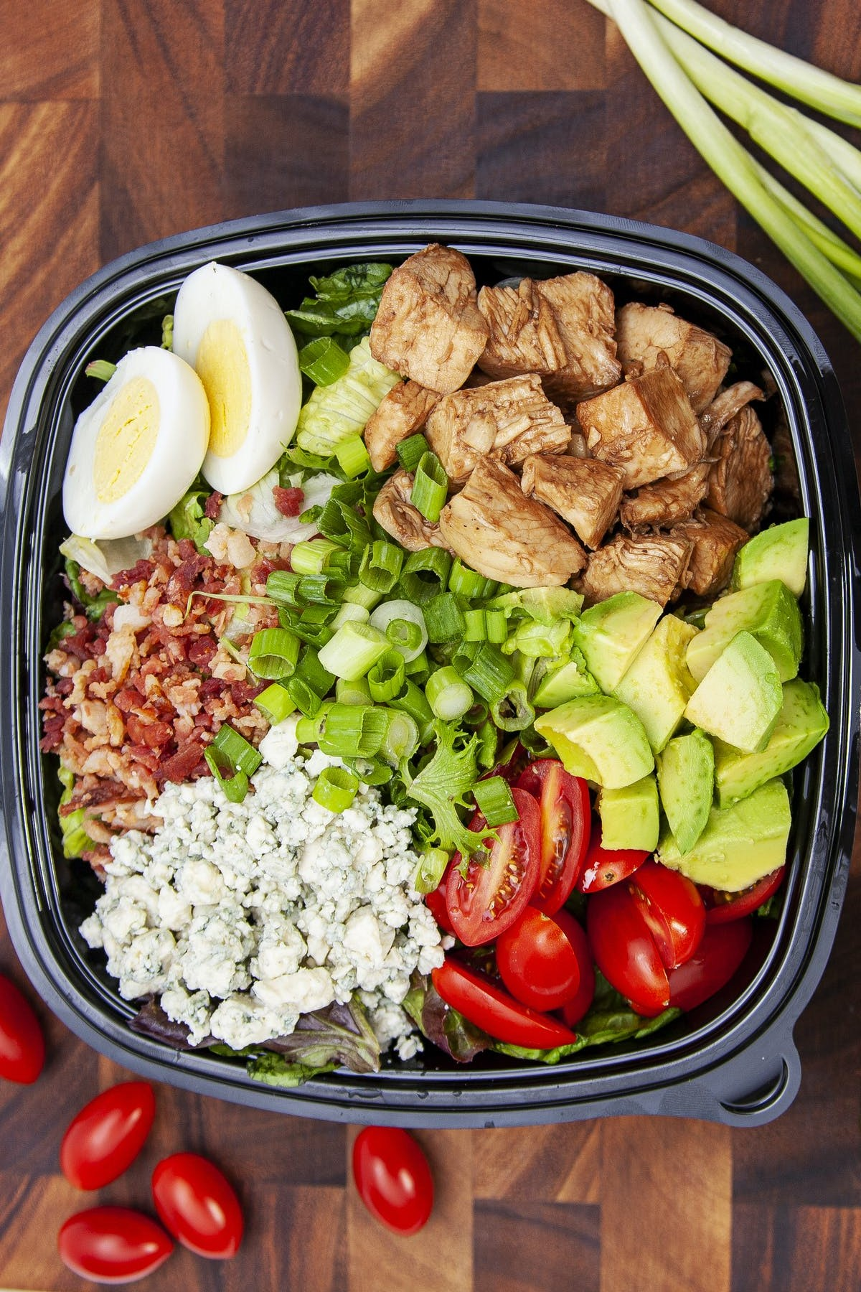

* REMOVE WHITE FRAME (remove that box) and update text

**DESCRIPTION** under this option, and bullet points, need following update: 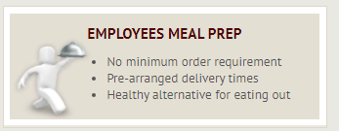

* REMOVE WHITE FRAME (remove that box) and replace Title in this box with:

**HEALTHY ALTERNATIVE TO EATING OUT**

* REPLACE bullet point text with:
* Daily FREE Delivery
* No minimum order requirements
* Pre-arranged delivery times

**ALSO CHANGE text** inside this ORDER button into See more…



* REPLACE icon  with new one (FREE DELIVERY)

**TEXT UPDATES INSIDE CUSTOMIZATION (PICTURE BELOW) POUP**

*This popup opens once you select customize option for all SALAD menu items

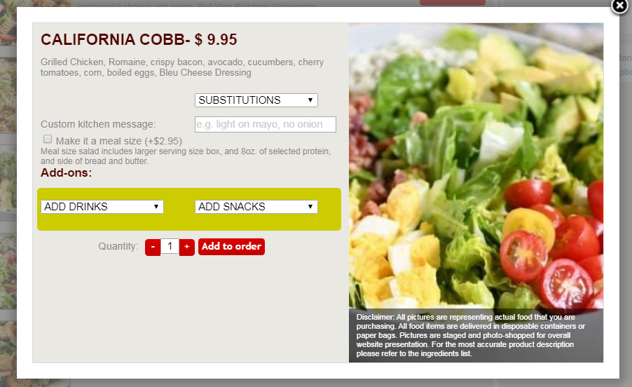

**REPLACE** text ‘Make it a meal size (+$2.95)…' into following (below text):

Make my salad Dinner Size (+3)

**ADD SPACE** between this and Add-ons: (*this should apply to all not only SALADS customization popups)

MENU CATEGORIES on picture below are not very visible – need solution(??)

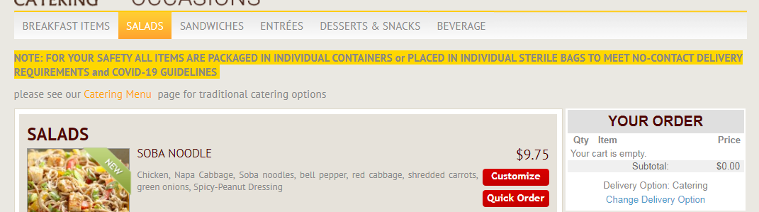

When you open this page above additional Menu pages need following update:

BREAKFAST ~~ITEMS~~ I SALADS I SANDWICHES I ~~ENTREES~~ I ~~DESSERTS & SNACKS~~ I  ~~BEVERAGE~~

replace with:

**BREAKFAST I SANDWICHES I SALADS I HOT LUNCH I SWEETS & SNACKS I DRINKS**

* Also it NEEDS TO BE BIGGER BOLDER and hoovering background should be RED instead of ORANGE because this section is hard to notice (as you can see on sample picture)

CHECK OUT UPDATES

Once on checkout page:

* Add space between text and box and Make box for coupon code little taller (bigger)

CHECKOUT AND PAY button (DELETE “with ATM or CREDIT CARD”)

* MOVE IT to the right of “< Continue shopping” place it right underneath TOAL and Amount

PAY BY CHECK DELAYED BILLING…

* make this button bigger and add: With Unique COMPANU CODE under CHECKOUT on this button

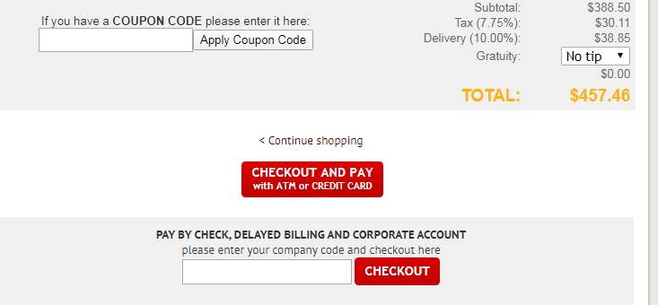

* INCREASE ordering requirement from 24 hours to 48 hours in calendar (on CATERING checkout page) ‘select delivery date’

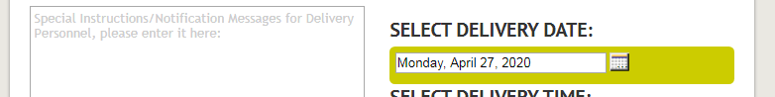

CONTACT US PAGE UPDATES (below)

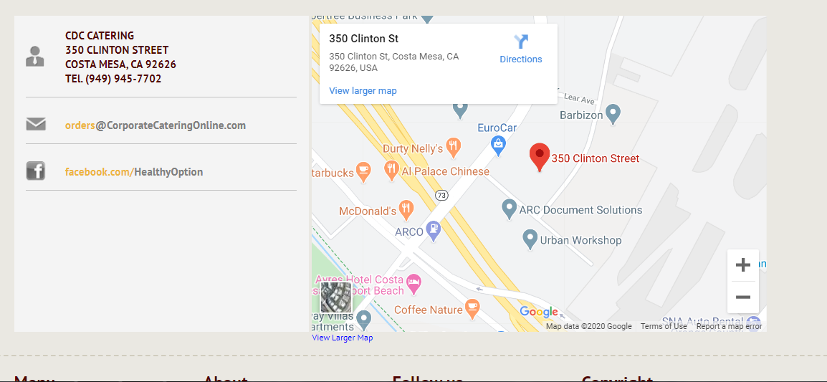

UPDATES NEEDED on contact us page:

* Add CORPORATE CATERING ONLINE on top and above CDC CATERING
* 350 Clinton Street (lower case letters)
* Costa Mesa, CA 92626 (lower Case)
* Tel. (949) 945 7702 (lower case no – on phone number)
* In below empty space list following:

Dominique Douglass, Head Chef e. chefdom@cdccatering.com

Robert Whitaker, Sous-Chef e. cheflu@cdccatering.com

Alexus Brent, Account Manager e. alex@corporatecateringonline.com

Grada Lucas, Owner e. grada@corporatecateringonline.com

ALSO NEEDED, need to zoom-out current view – simply click x 2 on – (minus) button and position on google view will update to desired (please see below):

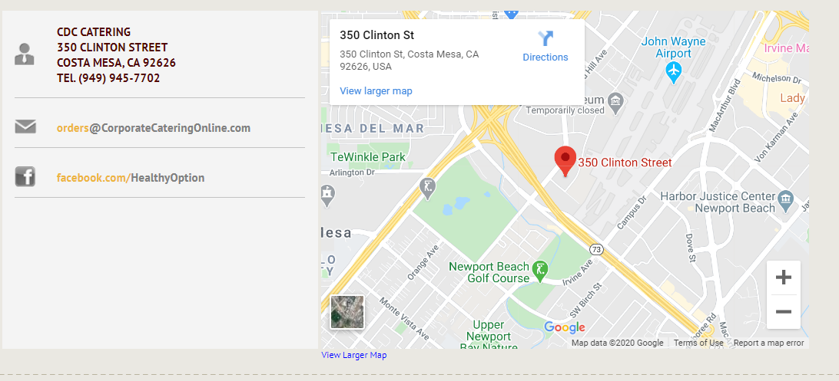

DESSIRED VIEW on Google maps (above)